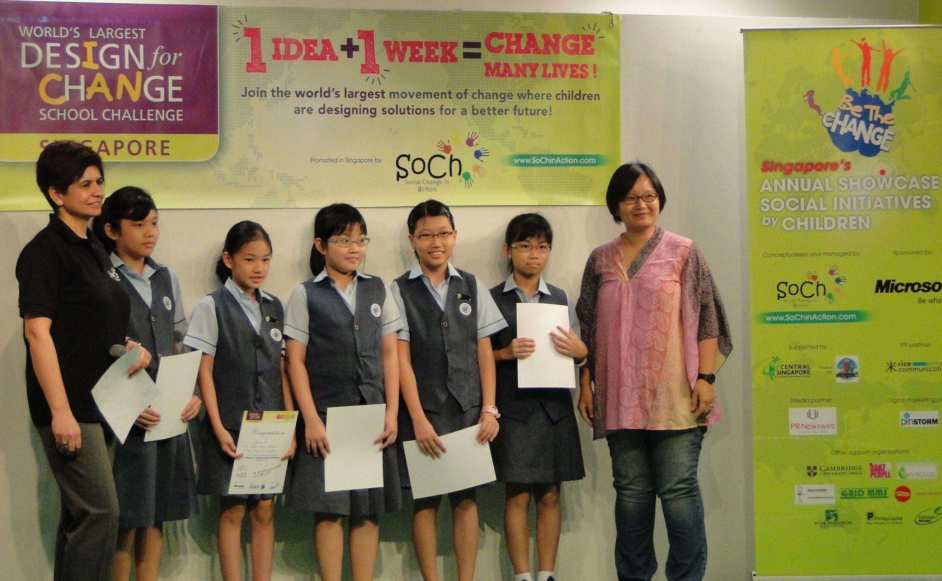

Be part of the **World’s Largest Change Movement by Children**

Watch the impact of **Design for Change** Challenge on children <http://www.ted.com/talks/kiran_bir_sethi_teaches_kids_to_take_charge.html>

Watch the **The Exposition** 2010 and 2011 videos held in Singapore

[Exposition 2010](http://www.youtube.com/watch?v=I-53akLq26I) and [BTC 2011](http://vimeo.com/32404913)

Visit **DFC global website**

[www.dfcworld.com](http://www.dfcworld.com)

Design for Change program empowers young children to believe that they matter; that change is possible and that they can lead & inspire change themselves

**Design for Change** (DFC) Singapore is part of a global movement that is reached 31 countries and 25 million children around the world.

In Singapore the program has been successfully running since 2010. In 2011, 80 teams from 30 local schools submitted their projects that tackled real issues in the community.

Eminent local judges from IDEO, Singapore Children’s Society, IDEO, Ashoka, NVPC and MOE have been part of our panel to select winners.

**Be the Change Exposition annually** showcasesthese innovative projects by children. In 2011 over 300 students shared their work with many teachers, students and parents at the event.

I am writing to you to explore possibilities of your organisation associating with an interesting social program focusing on empowering children aged 9-14years; Design for Change.

Design for Change School Challenge is an innovative program that aims to give children an opportunity to pull into action their own ideas for a better world. They get directly involved in designing and leading change in their communities. A very hands-on approach!

Participating children are given simple challenge: One Idea; One Week; Change many lives! Winners are chosen under categories and ‘experiential’ prizes are then awarded. It doesn’t end there!

In Singapore only, all projects are shared at the largest showcase of social initiatives by children at Be the Change Exposition annually.

We are looking for sponsors and hoping to discuss this further with the concerned person.

A program that is inspiring many children across the world to say

***‘I Can!’***

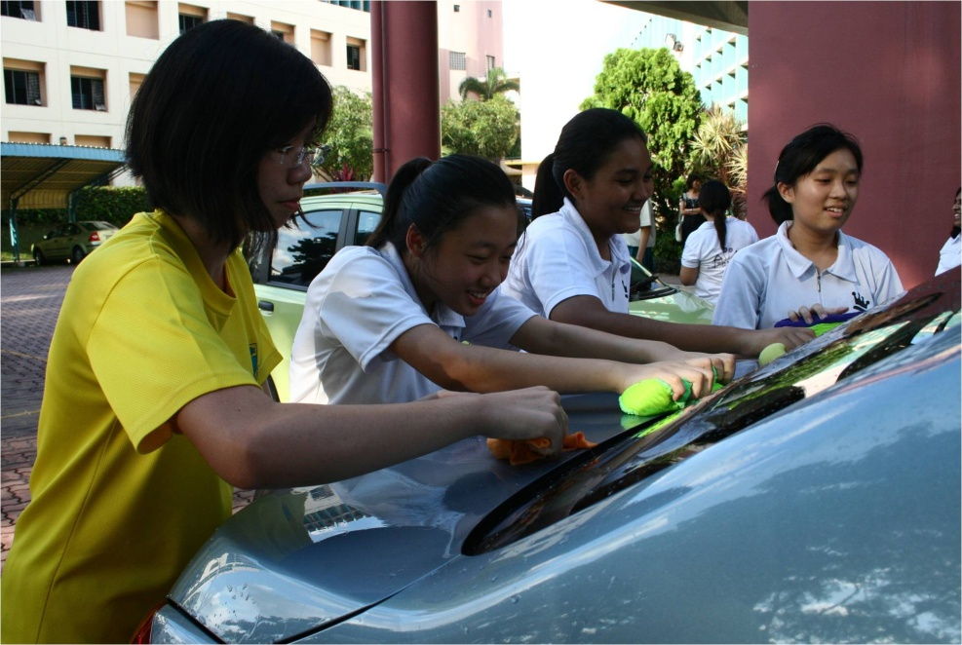

Supported in the past by Shell, Maybank, Microsoft and Central Singapore Community Development Council

SGD$750,000 worth of media exposure in 2011 through print, radio and online publications

RICE Communications has been our dedicated PR agency since 2010 <http://www.ricecomms.com/>

***Design for Change*** *Singapore program and* ***Be the Change Exposition*** *are managed by* ***SoCh in Action****, a social enterprise that focuses on promoting community projects through innovative and engaging programs. Since 2010 both the projects have been managed by dedicated team with a range of expertise and a passion for working with children. For more information visit* [*www.SoChinAction.com*](http://www.SoChinAction.com)

7

We are seeking an appointment to discuss this value proposition with you further. You can reach us via email or phone (details below)

Look forward to hearing from you.

Kind Regards,

*Madhu Verma Rayana Pandey*

[*madhu@sochinaction.com*](mailto:madhu@sochinaction.com)[*rayana@sochinaction.com*](mailto:rayana@sochinaction.com)

*91683442 97569010*

C:\Users\Verma\Downloads\Option One.jpg

*SoCh In Action*

[*www.SoChinAction.com*](http://www.SoChinAction.com)

Only social initiative program in Singapore focusing on children under 15years duled to be launched in February 2012 ; target of registering over 120 teams reaching out to every school in Singapore

Holistic program for children that *stimulates*; *initiates* *action* and promotes *peer learning* to empower children

Annual **Be the Change** **Exposition**; largest showcase of social initiatives by children in Singapore successfully running since 2010

International program customized & successfully run in Singapore since 2010

Design for Change School Challenge

Singapore 2012

Your Brand CAN